CIT 0633

CentOS 7
INSTALLATION MANUAL

VMware Player is a free virtualization software from VMware that allows you to run one operating system within another operating system. You can, for example, install a Linux distribution within your Windows OS – there is no need to dual-boot.
CentOS is a popular Linux distribution based on Red Hat Enterprise Linux. In this chapter we will describe how you can install CentOS on VMware Player in Windows.

Requirements:
1. CentOS (CentOS-7-x86_64-DVD-2009)
2. VMware Player (VMware-player-15.5.7-17171714)

3. Check virtualization: Task manager>performance>CPU- virtualization: make sure is ENABLE

You will need to install 2 copies of Centos.
SVR1 (20Gb) 🡪 use for class exercise /server
SVR2 (20Gb) 🡪 use for Labwork / client

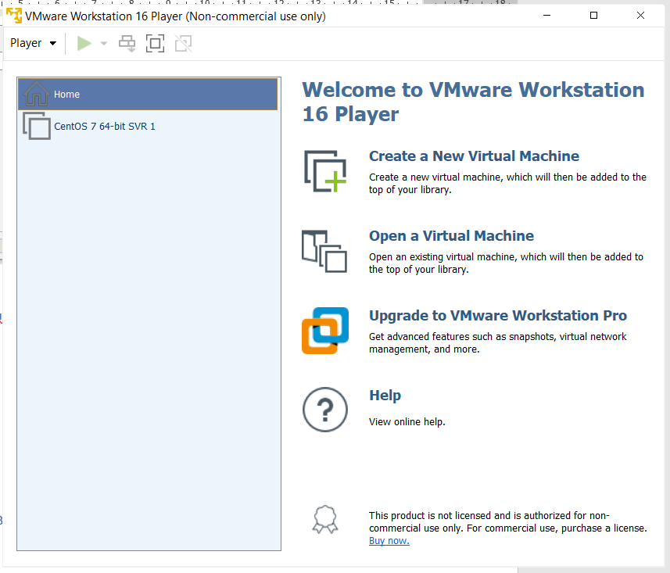
1. Click “Create a New Virtual Machine”.

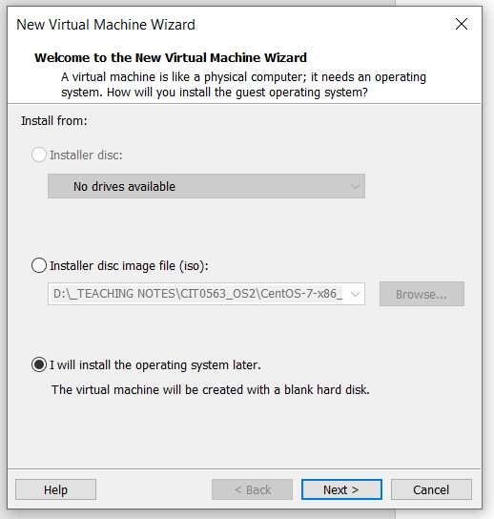
2. Choose “I will install the operating system later.”
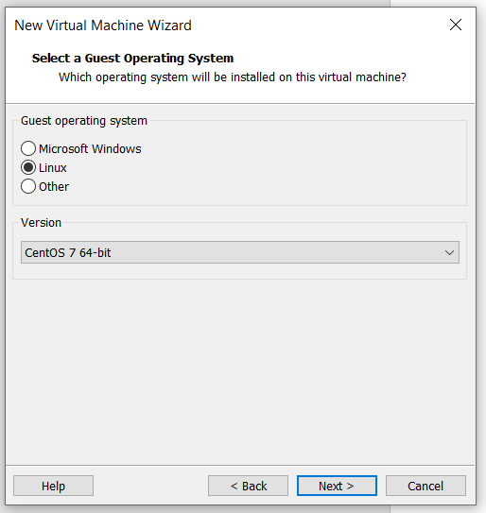
3. Choose Linux, and Centos 7 64-bit.

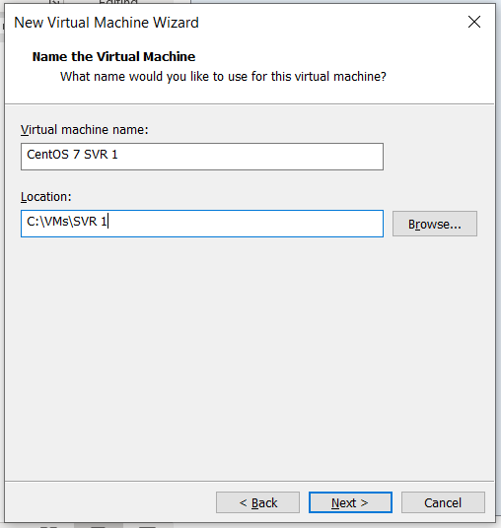
4. Virtual machine name: CentOS 7 SVR 1
(on SVR 2, virtual machine name : CentOS 7 SVR 2)
Location: create a folder and choose the folder as the location of the VMware files.
SVR1 and SVR2 need to be put in different folder – 1 folder for SVR1 , and another folder for SVR2.

Make sure the location is not pointing to ONE DRIVE.

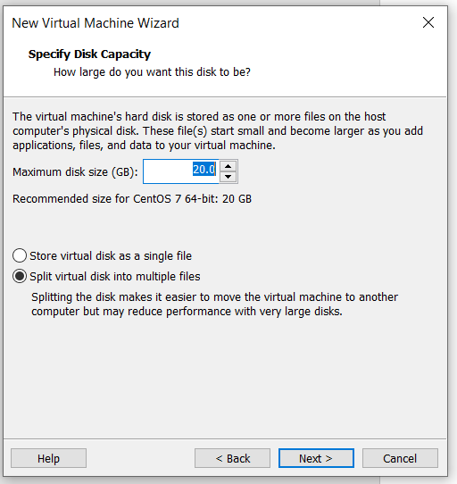
5. Maximum disk size: 20GB
Choose “Split virtual disk into multiple files”.

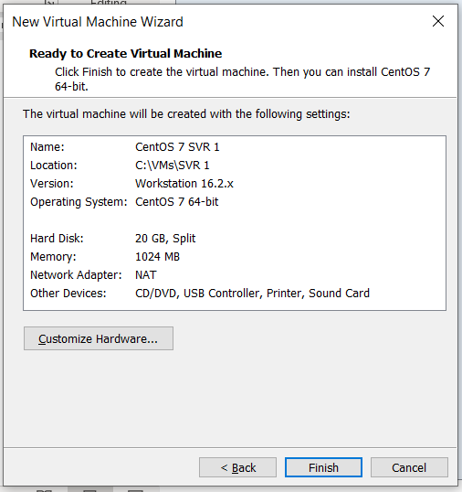
6. Click Customize Hardware
Memory: 1 GB (by default)
Processor: 1 (by default)
Network adapter: NAT (by default)

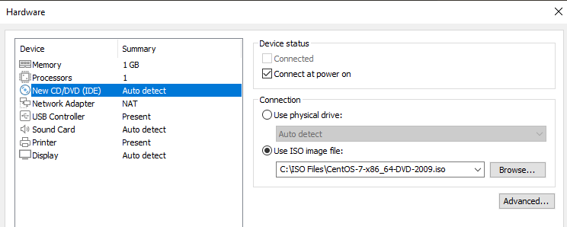
7. Click on New CD/DVD (IDE), choose “Use ISO Image File”. Browse the location of your CentOS 7 ISO file. Click Close.

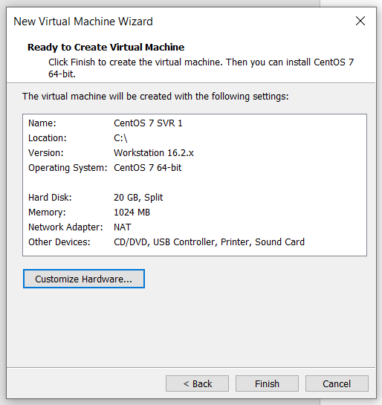

8. Double check the information. Click Finish.

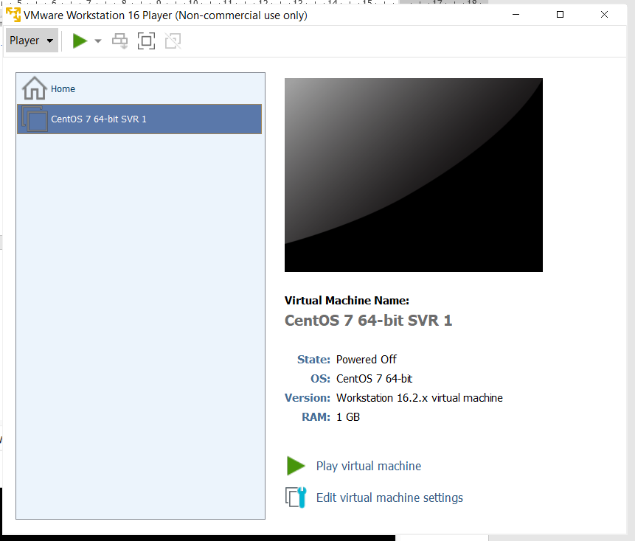
9. Click on Centos SVR 1 on the left panel, then click “Play virtual machine”.

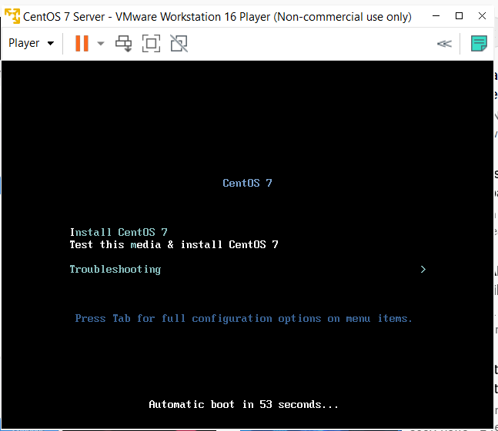
10. On the first screen, select Install CentOS 7 then press Enter.
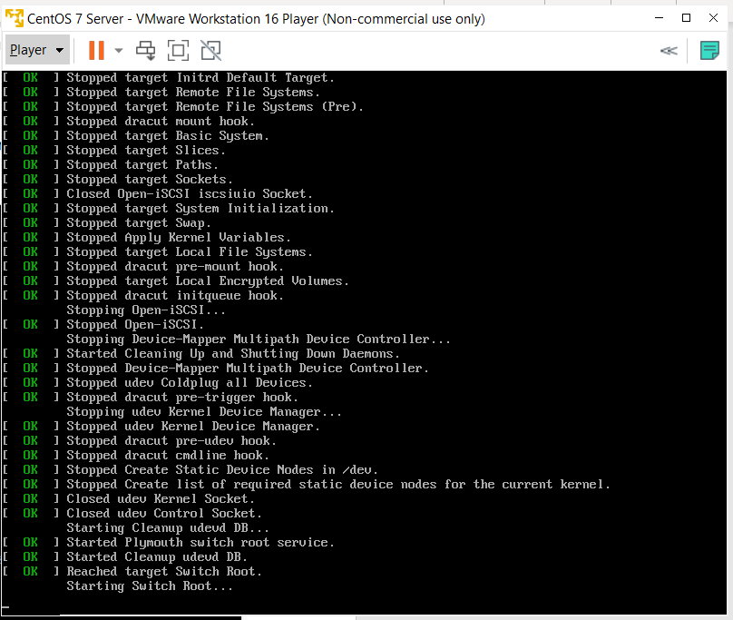
11. The operational system is going to load some resources, wait until you are presented with the welcome and language selection screen:

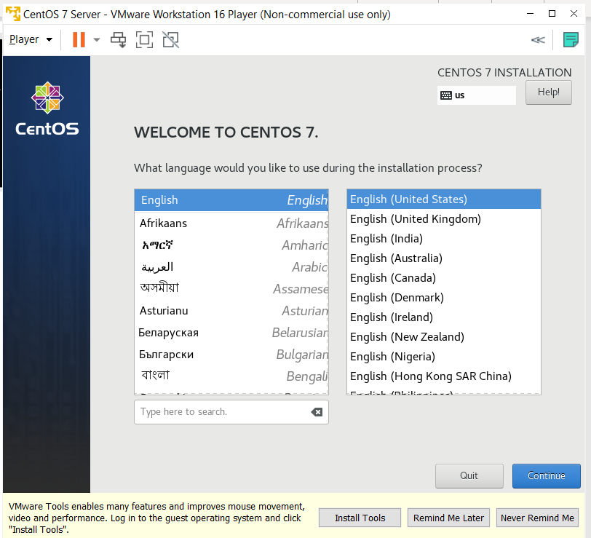
12. Select your language and hit Continue in the right bottom of the screen.

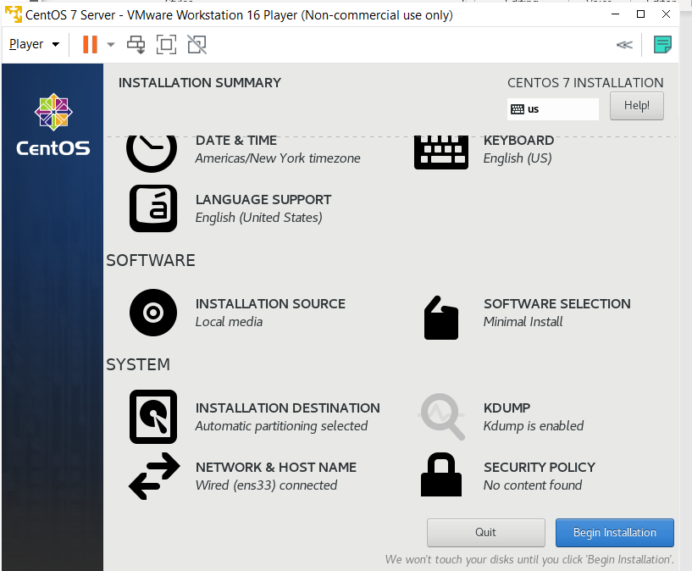
13. Now, you are going to be presented with the screen above, where we are going to modify some necessary options before the installation begins.

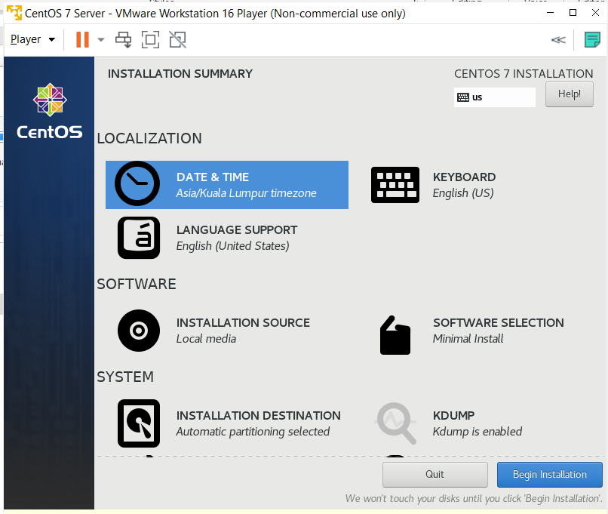
13. Click on DATE & TIME.

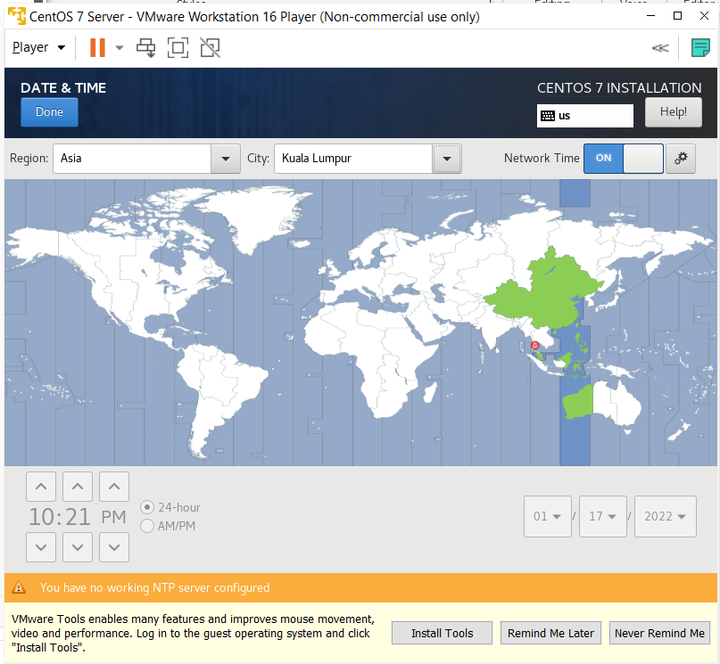
14. Enter the Religion, City, clock, and date accordingly. Click Done.

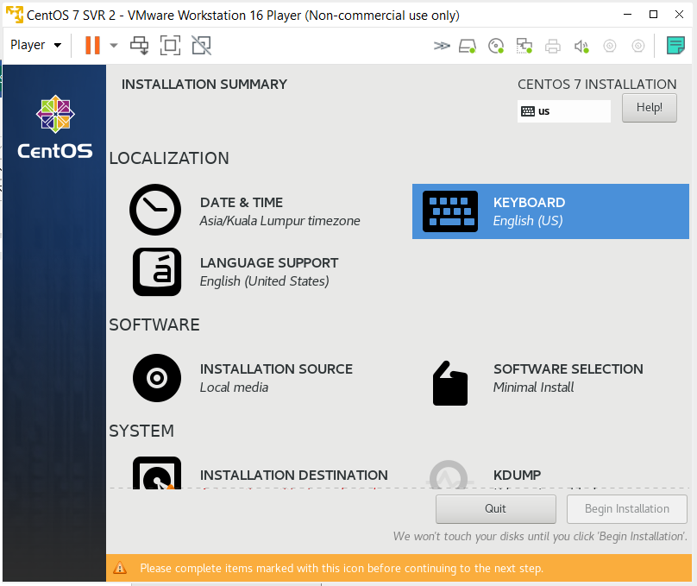
15. Click on KEYBOARD.
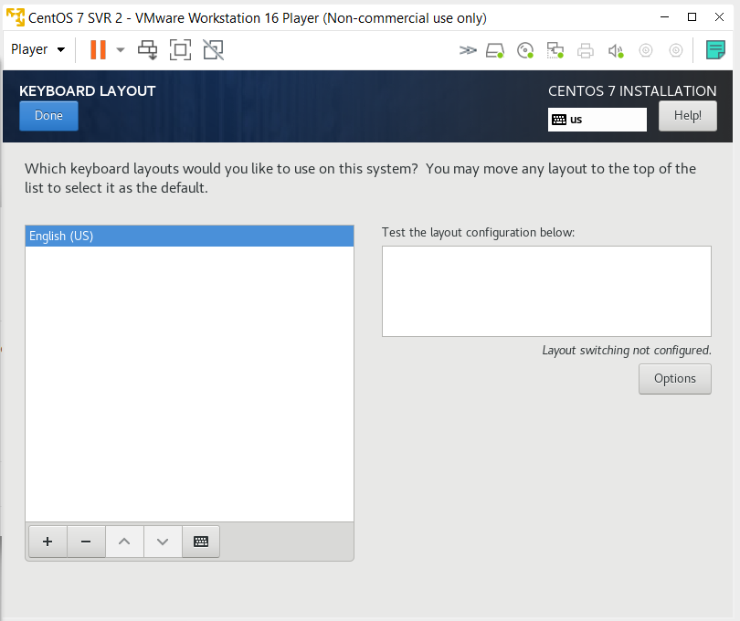
16. Choose English (US).

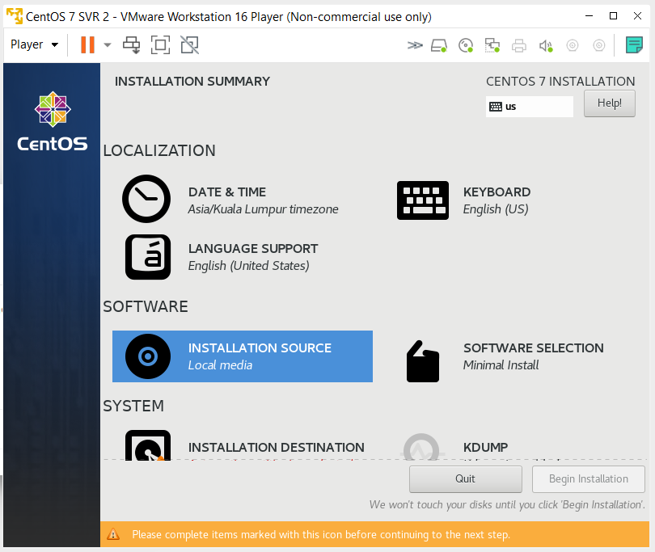
16. Choose INSTALLATION SOURCE.

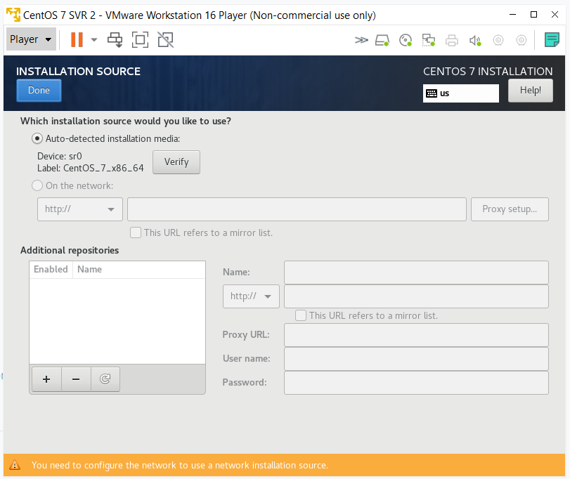
17. Choose Auto-detected installation media. Click Verify. This is to verify the source of .iso files is valid to be used later.

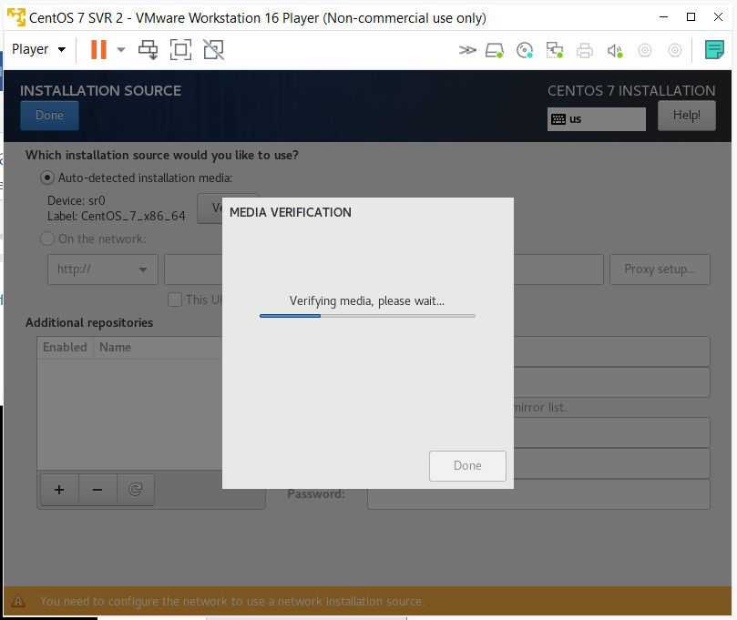
18. Verifying media.
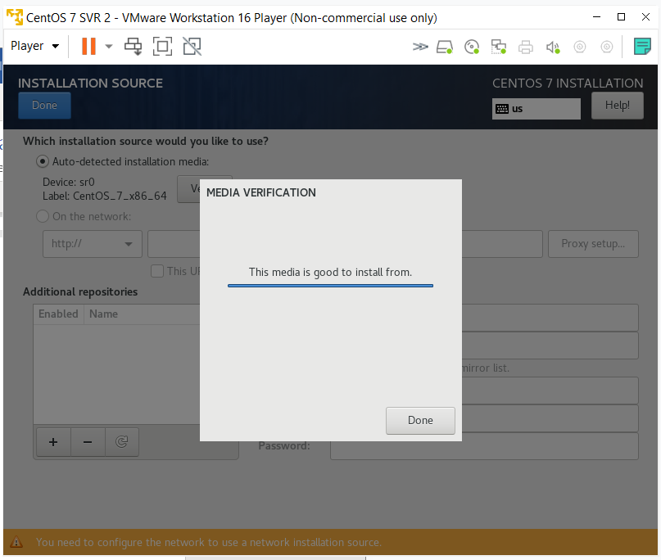
19. Click Done.

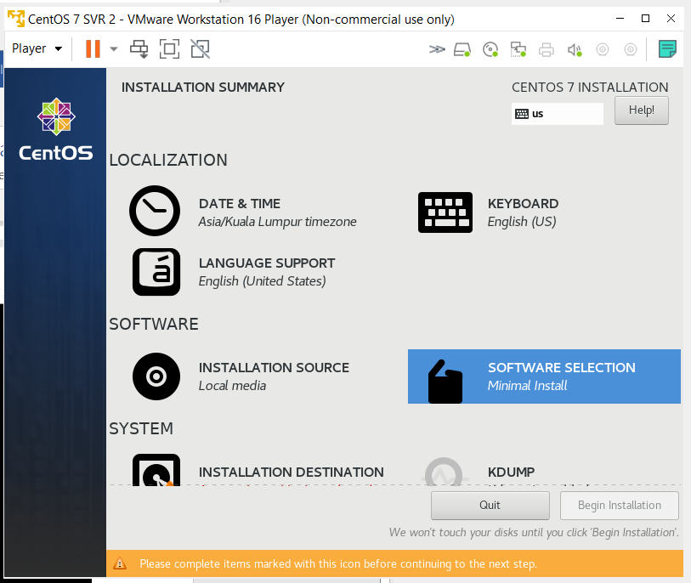
20. Click on SOFTWARE SELECTION.

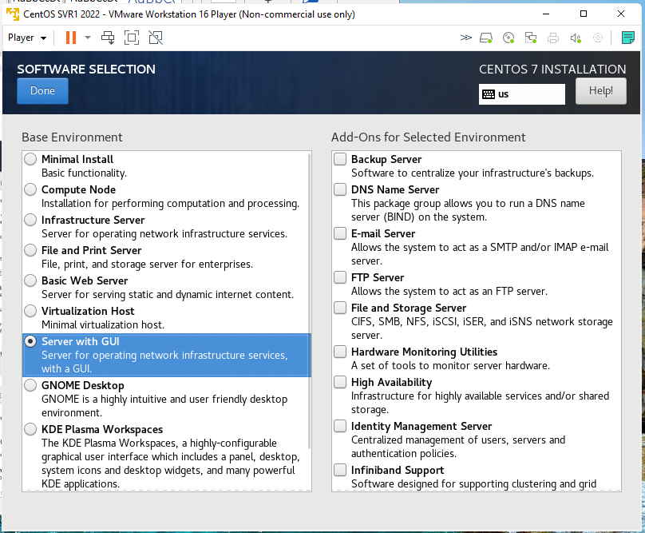

21. Choose as below:
Base Environment: Server with GUI
Click Done after the selection.

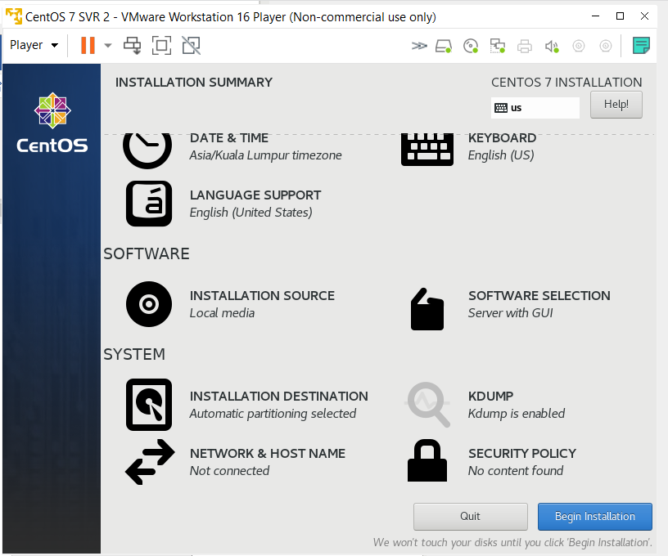
22. Click on INSTALLATION DESTINATION.

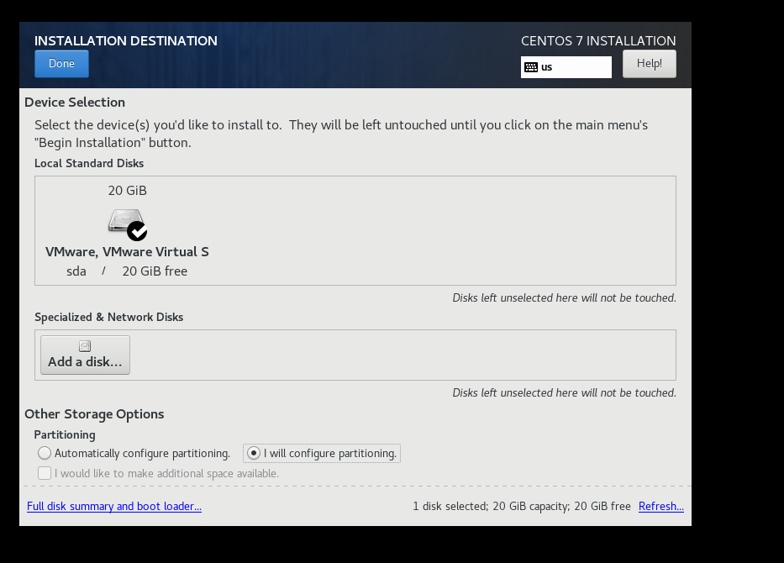
23. Click on “I will configure partitioning” in Partitioning. Click Done.

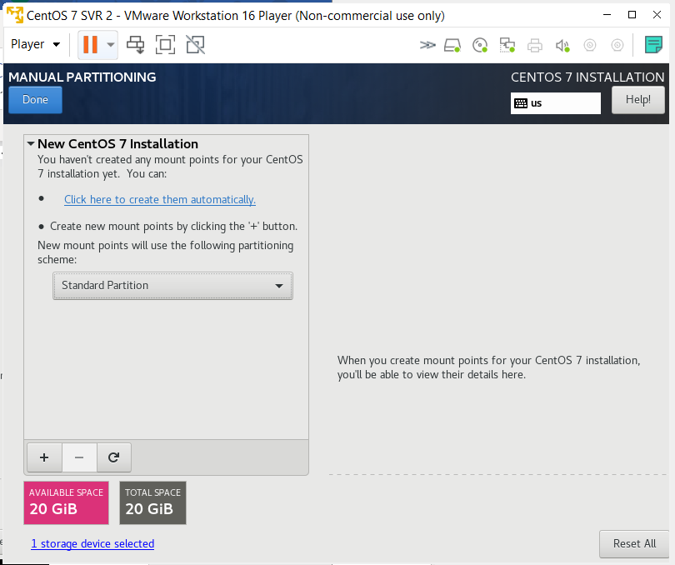
24. Choose Standard Partition
Four partitions must be created, the name and label, size, mount point, type, and file system should be distributed like the following:
Partition | Mount Point | Type | File System | Size (MB)
boot | /boot | Standard | xfs | 200
root | / | Standard | xfs | 10240
home | /home | Standard | xfs | 5120
swap | - | Standard | swap | 2048

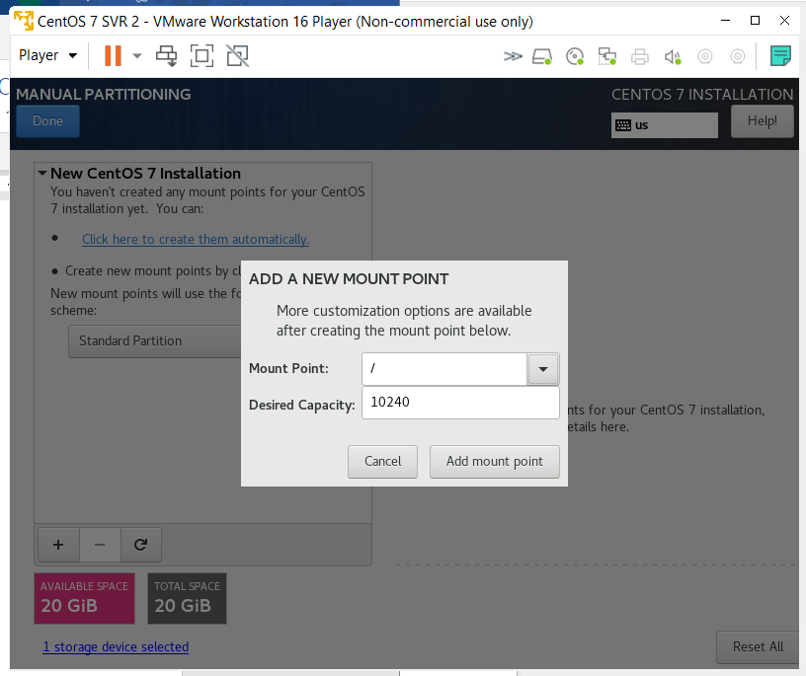
25. Click on ‘+’ sign to add a new mount point for the boot partition. Enter the detail as above.
Click on ‘Add mount point’.

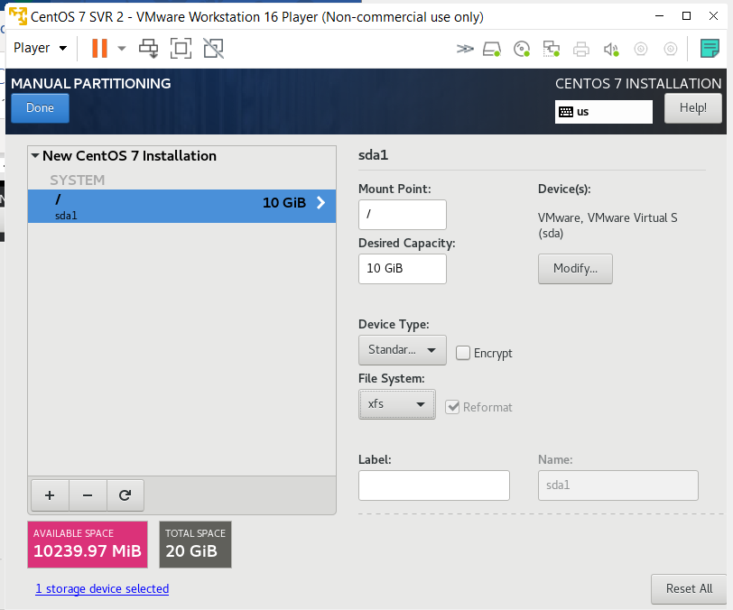
26. The result as above.
Click ‘+’ sign to add others partition.
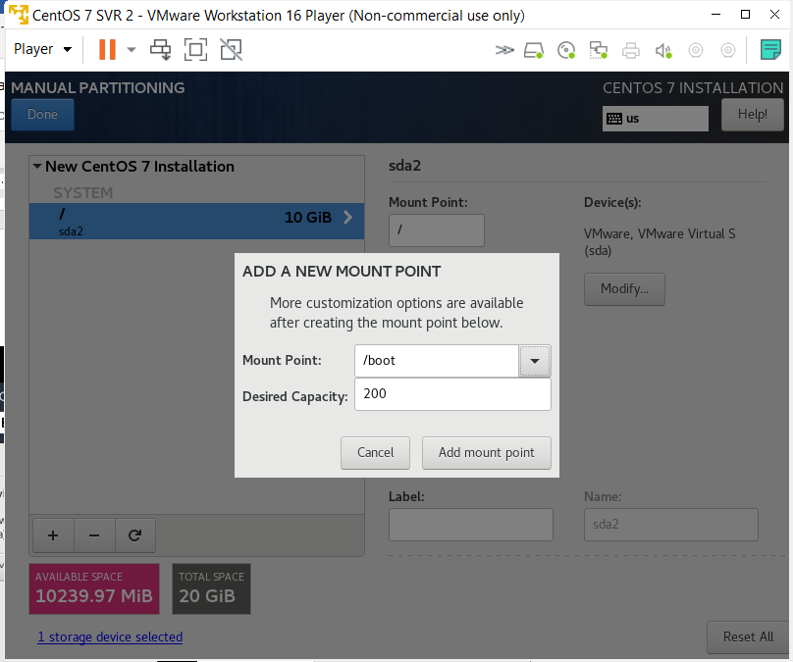
27. Enter the detail as above.
Click on ‘Add mount point’.

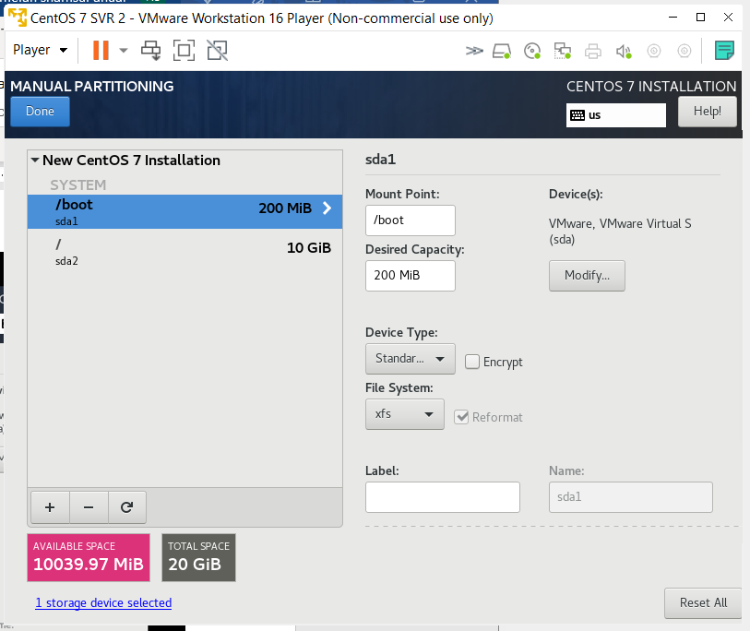
28. The result as above.
Click ‘+’ sign to add others partition.
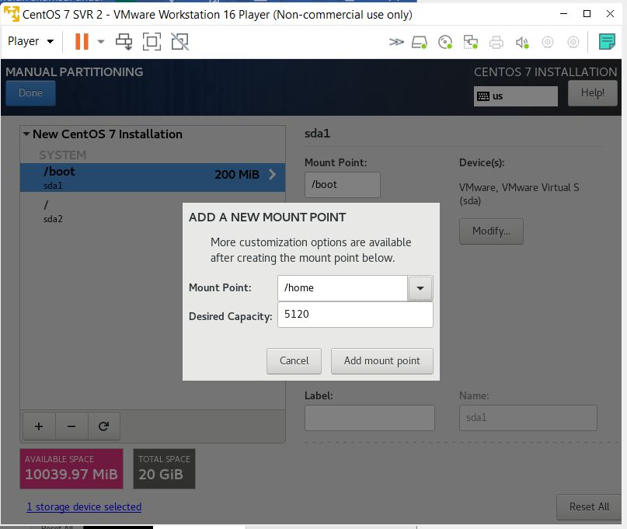
29. Enter the detail as above.
Click on ‘Add mount point’.
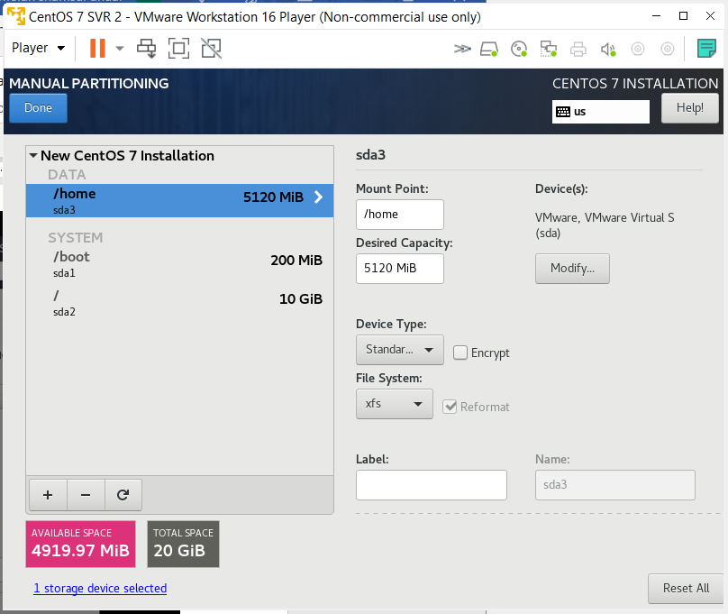
30. The result as above.
Click ‘+’ sign to add others partition.
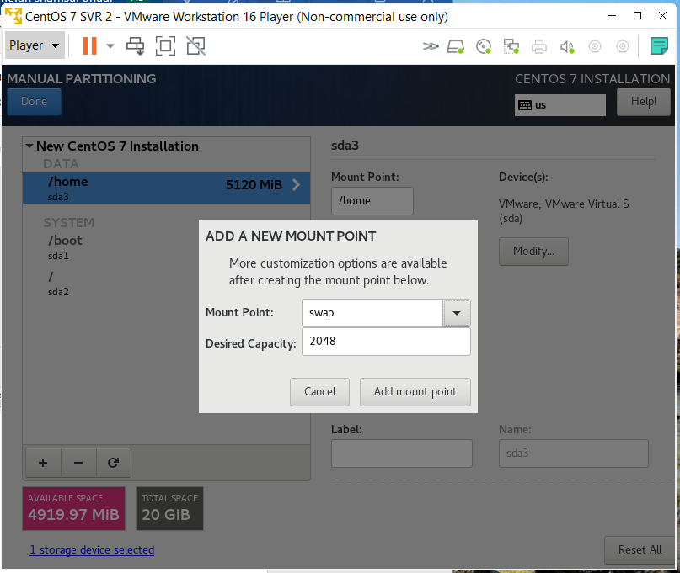
31. Enter the detail as above.
Click on ‘Add mount point’.
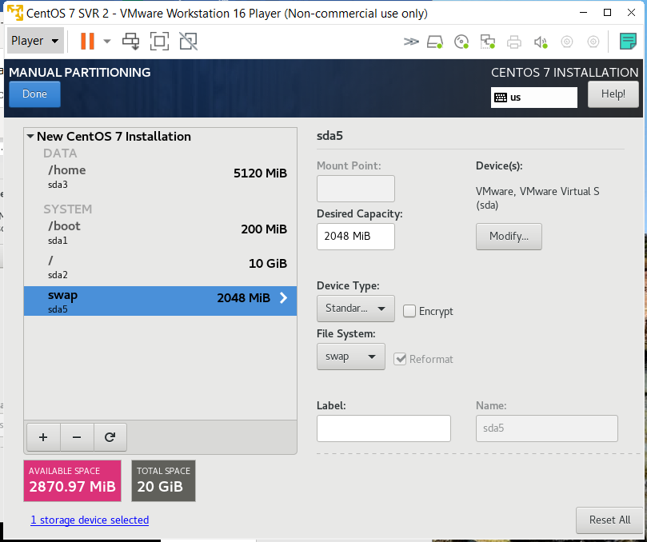
32. The result as above.
Double check all the info, before click Done.

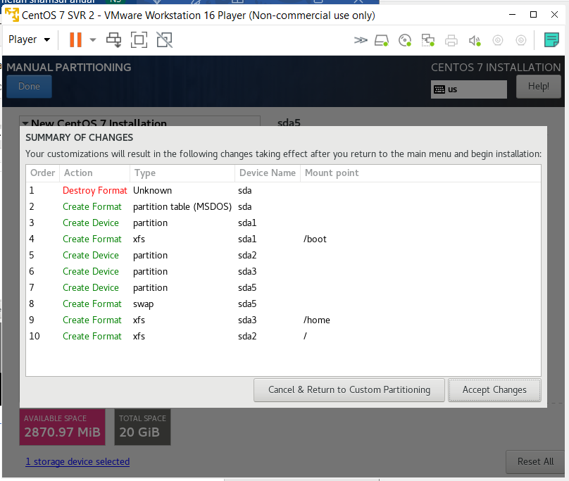
33. A screen will appear showing the changes that are going to be made on your disk, just hit Accept Changes to return to the main screen.
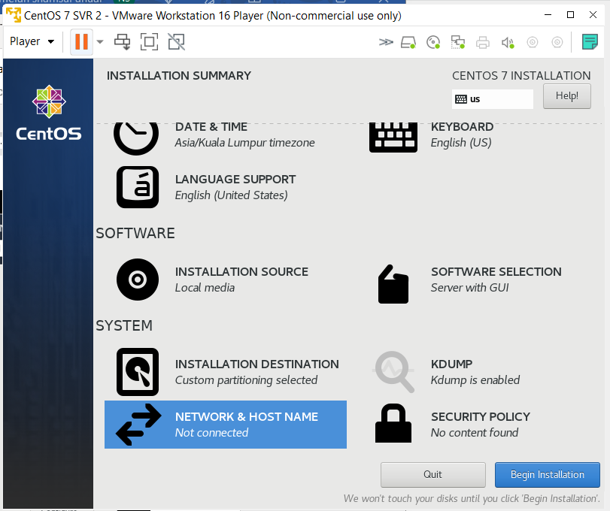
34. Click on NETWORK & HOST NAME.
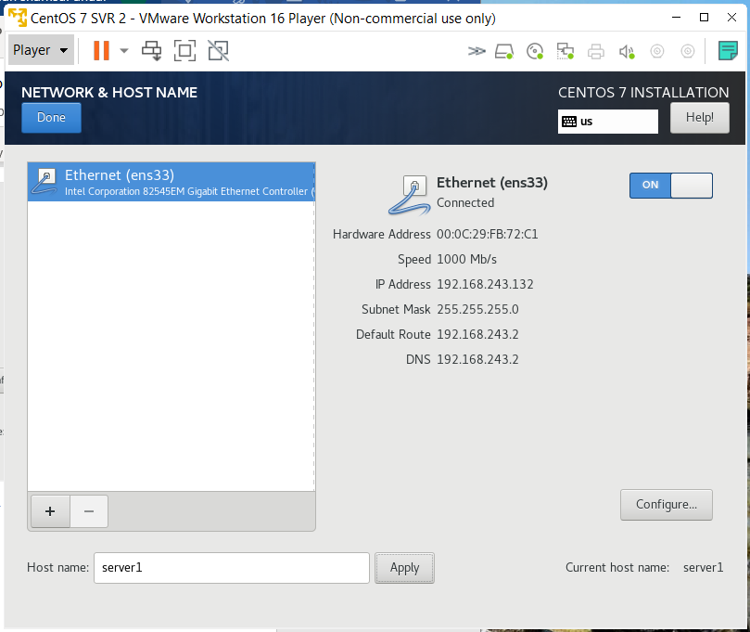
35. Enabled by default the network adapter, so it gets enabled automatically when CentOS starts.
Enter server1 as the Host name. Click Apply button.
Ensure the Current host name is server1.
Next, hit Done button.

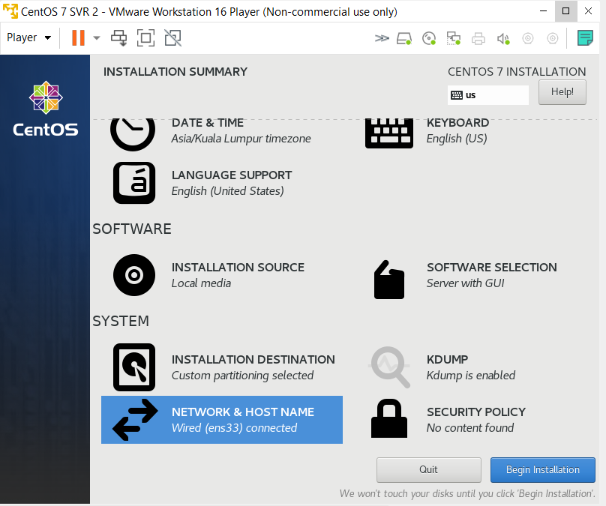
36. Finally hit the Begin Installation button to start the process. Whilst the system gets installed, don’t forget to set the root password, and create a user to log into the system:
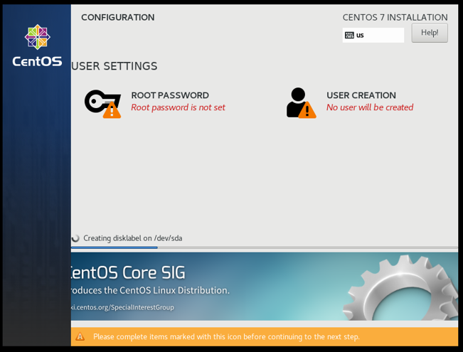
37. Click on ROOT PASSWORD to set the root password.

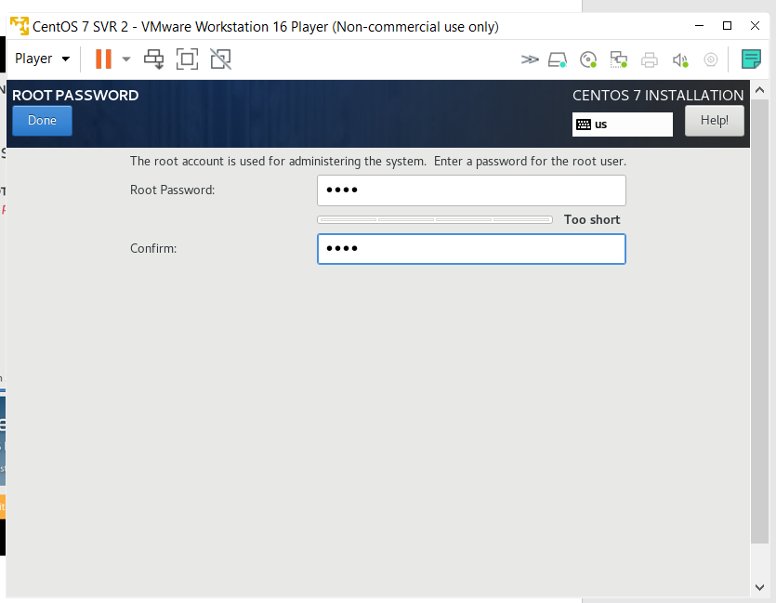
38. Root Password: toor
Click Done button twice.

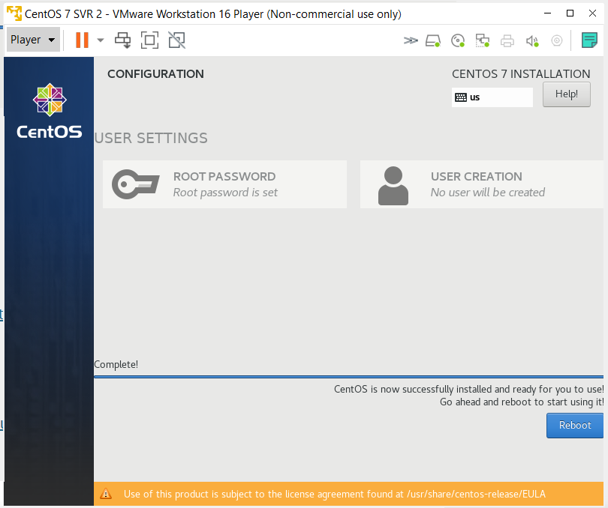
39. Click Reboot button.

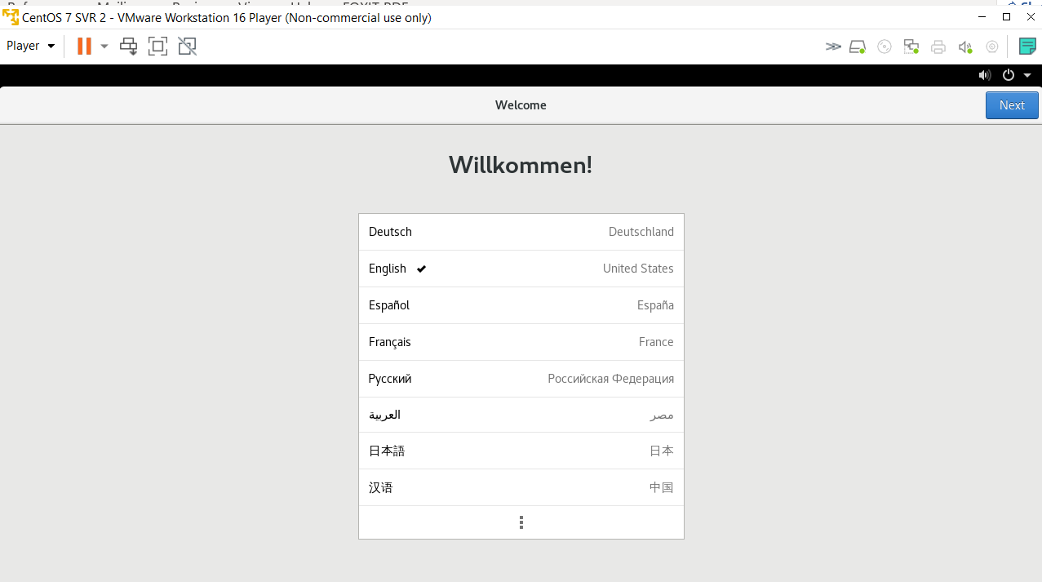
39. Select English, click Next button.
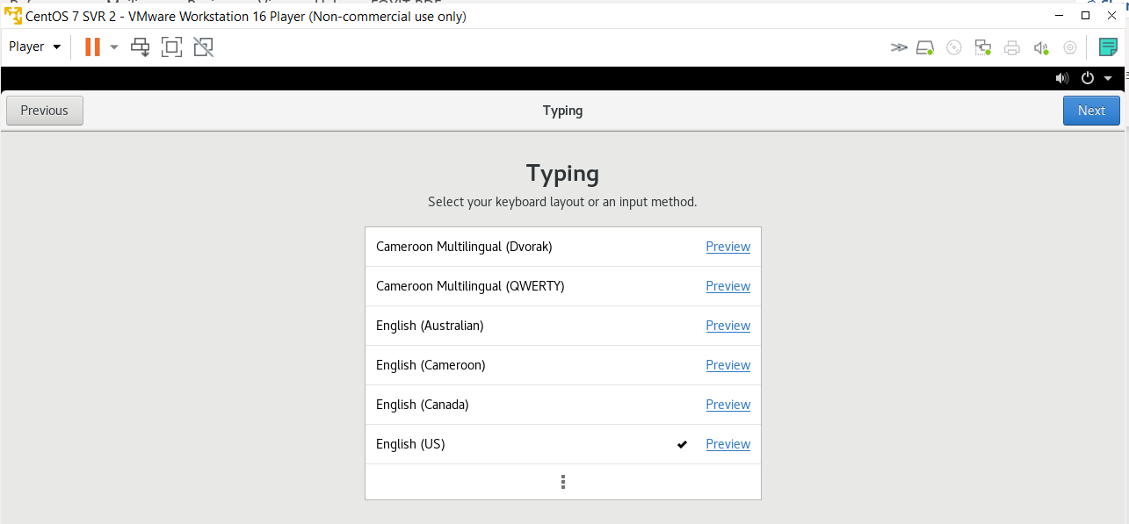
40. Select English (US), click Next button.

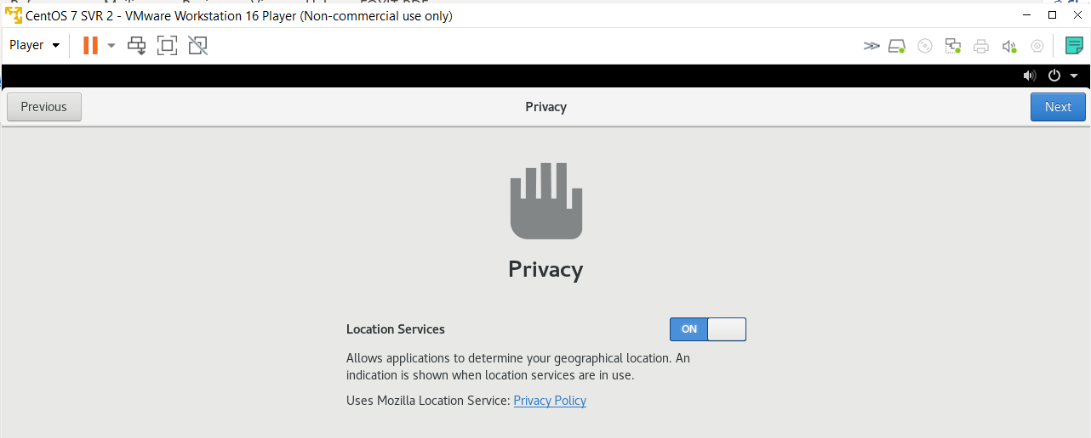
41. Enable the location services, click Next button.
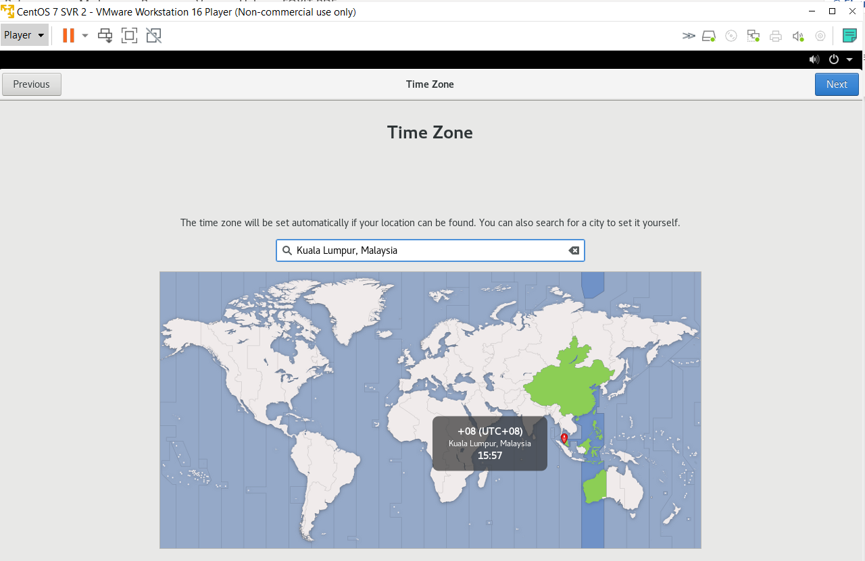
42. Select “Kuala Lumpur, Malaysia” as the location.

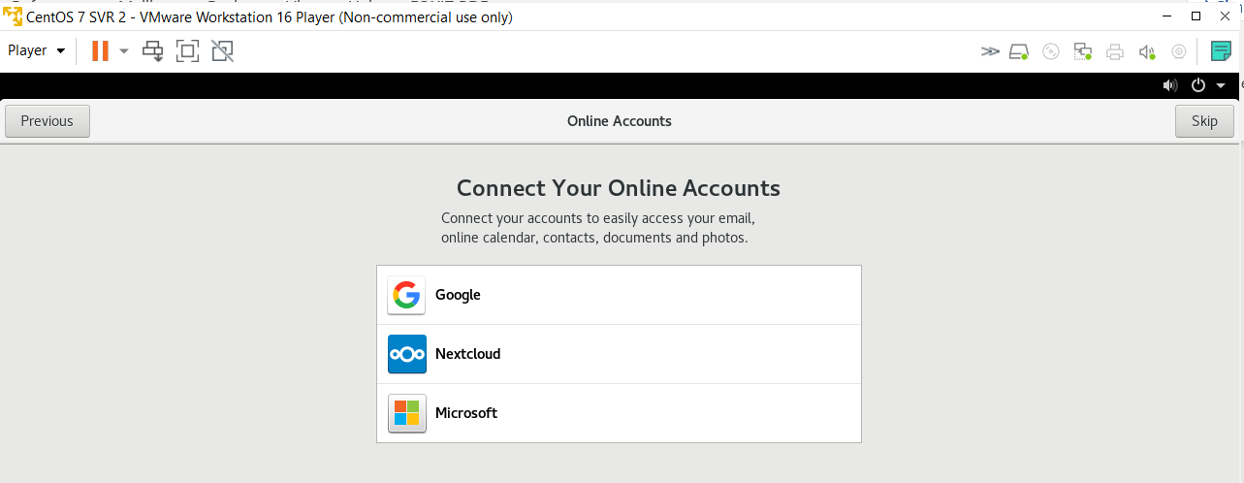
43. Click Skip button.
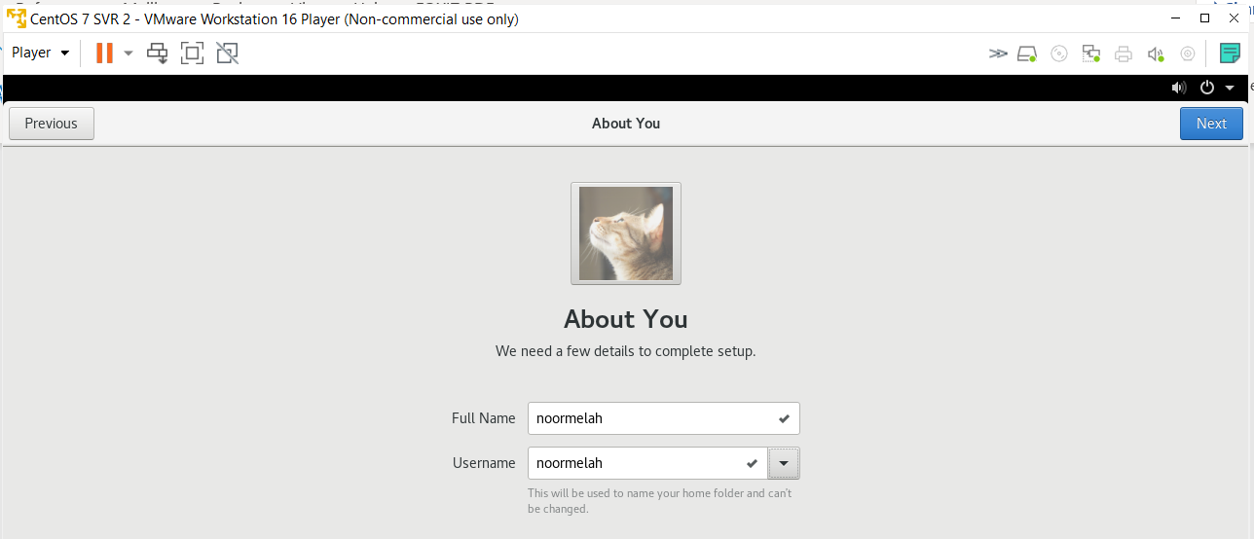
44. Put your own name in the Full Name and Username.
Please put your real name. Do not put anonymous name.
Click Next.

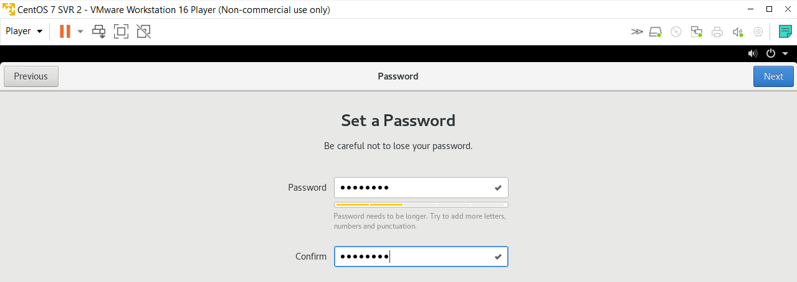
45. Put the password as:
toor@GMI

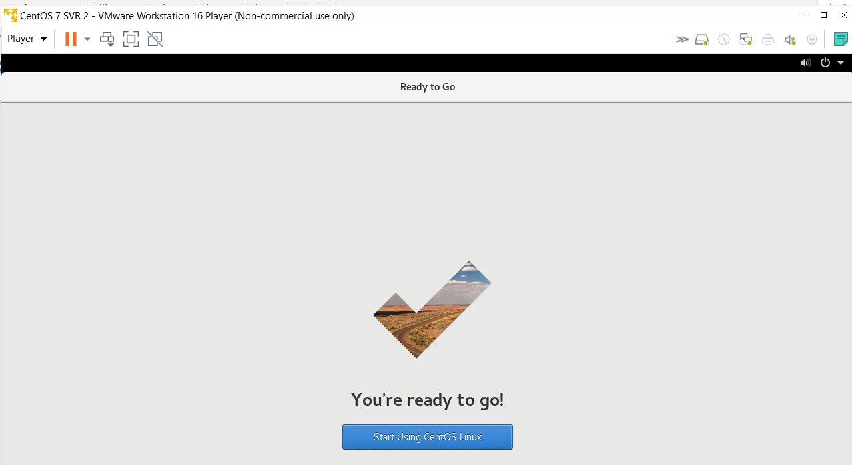

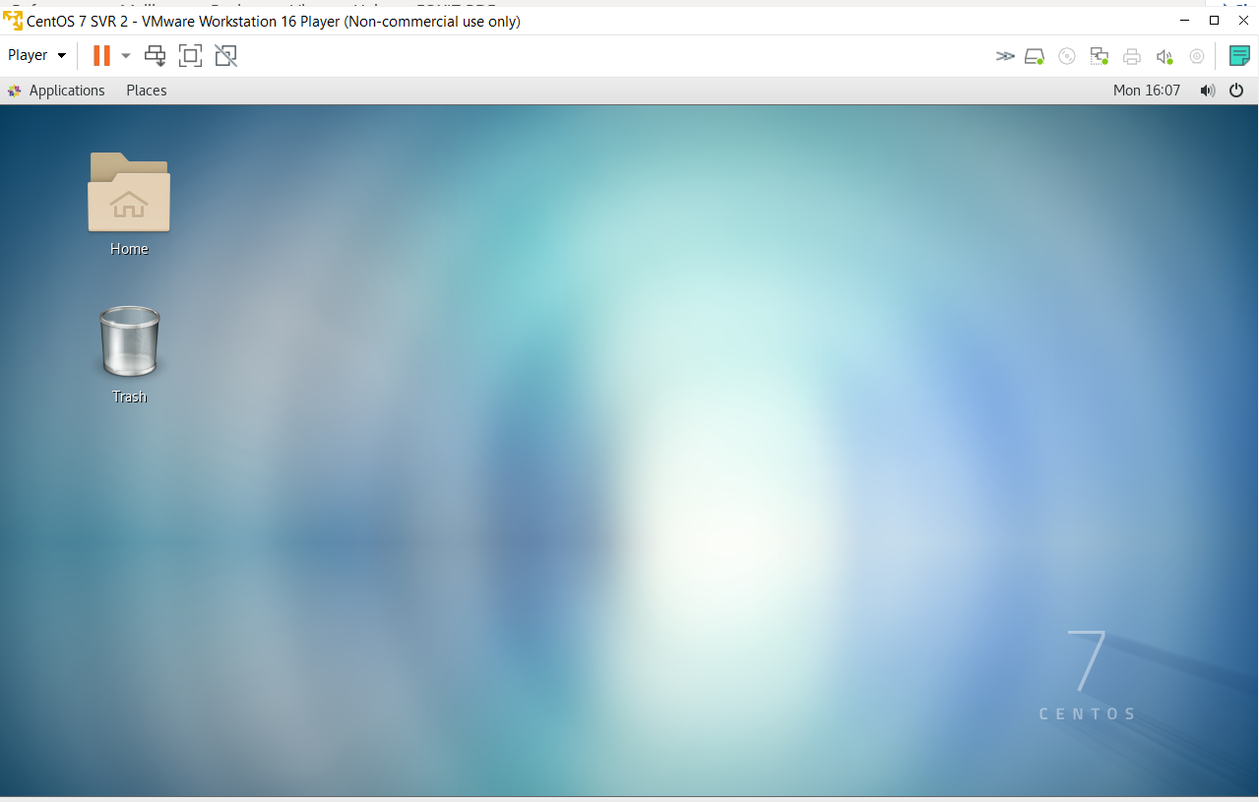
Complete!
Now, do the same step, but for SVR2.
Make sure SVR1 can ping SVR2.
- Enable wired connection (Application->System Tools -> Settings->Network)
- Open Termnal - ifconfig to get IP address
- ping to test connectivity. Make sure connection is successful.
Good Luck!



